Women’s History
S C O T L A N D

2013 Annual Conference
Centre for Nordic Studies, UHI, Kirkwall, Orkney
3-5 May 2013

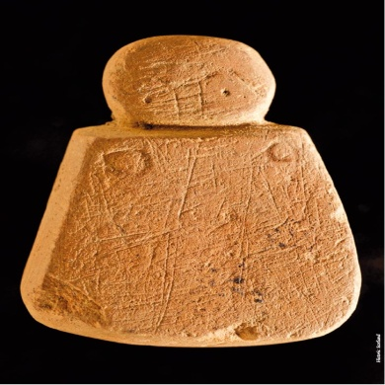
Orkney 'Venus' - http://www.educationscotland.gov.uk/scotlandshistory/earlypeople/orkneyvenus/index.asp

Making, Creating, Producing:
Historical Perspectives on Women, Gender & Production

CALL FOR PAPERS

This year’s annual conference will take place in Orkney and our theme explores the historical experience of women's relationship with production of things, of services and ideas - in the workplace and in the home, unpaid and paid. We welcome proposals relating to all historical periods (eg. pre-history, classical, medieval, modern, contemporary) and all geographical places including Scotland. We welcome interdisciplinary and comparative approaches and given the location of this event we particularly welcome proposals with a Northern Isles focus and reflections on experiences of production and reproduction in the wider Nordic context.

The following themes are offered as prompts for proposals but are not exclusive:
- relationship between paid and unpaid work
- perspectives on women's productive relationships with land and sea
- women/gender and craft production
- gendered approaches to making and creating
- production from the domestic to the global
- women and trade/business
- gendering the value of work
- gender and skill
- archaeological approaches to women/gender and production

The conference will be hosted by Orkney College, part of the University of the Highlands and Islands. WHS is keen to extend its activities outwith the central belt and to engage with scholars and those with a keen interest in women's history in the community.

We welcome proposals for a) papers of approximately 20 minutes in length or b) short presentations, from scholars at all stages of their careers and from independent researchers. Proposals of around 300 words, together with a brief biography (maximum of 100 words), should be submitted to Laura Paterson, l.paterson@dundee.ac.uk by 31 January 2013.

Travel to Orkney: by air: direct flights from Glasgow, Edinburgh and Inverness to Kirkwall; by sea: ferries from Scrabster and John O'Groats. Full details at http://www.visitorkney.com/gettinghere.asp
Accommodation: details of accommodation options will be provided closer to the conference.

